Data Flow Diagram
Date | 29 September 2026
Team ID | SWTID-2026-8691
Project Name | Import Data using Transform Maps (Spreadsheet)
Maximum Marks | 2 Marks
Data Flow Diagram
Create a Data Flow Diagram (DFD) to show how data moves through your system - between external entities, processes, and data stores. Use the symbol legend below as a guide.
DFD Symbol Legend
Symbol | Name | Description
Oval / Rounded shape | External Entity | A person, organization, or system outside the project that sends or receives data (e.g., User, ServiceNow User/Admin).
Rectangle with numbered header | Process | An activity that transforms incoming data into outgoing data (e.g., Import Data, Transform Data, Validate Results).
Rectangle (solid fill, no number) | Data Store | A place where data is held for later use (e.g., Import Set Table, Target Table, Report / Dashboard).
Labeled arrow | Data Flow | The movement of data between entities, processes, and data stores, labeled with what data is being passed.
Data Flow Diagram – Import Data using Transform Maps
The diagram below illustrates how spreadsheet data moves through the Import Set, Transform Map, target table, and validation/reporting stages.
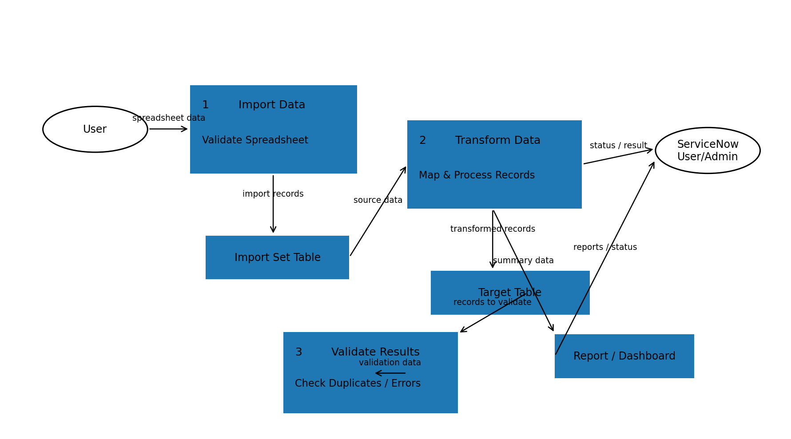
ServiceNow Team Project – Import Data using Transform Maps (Spreadsheet)

